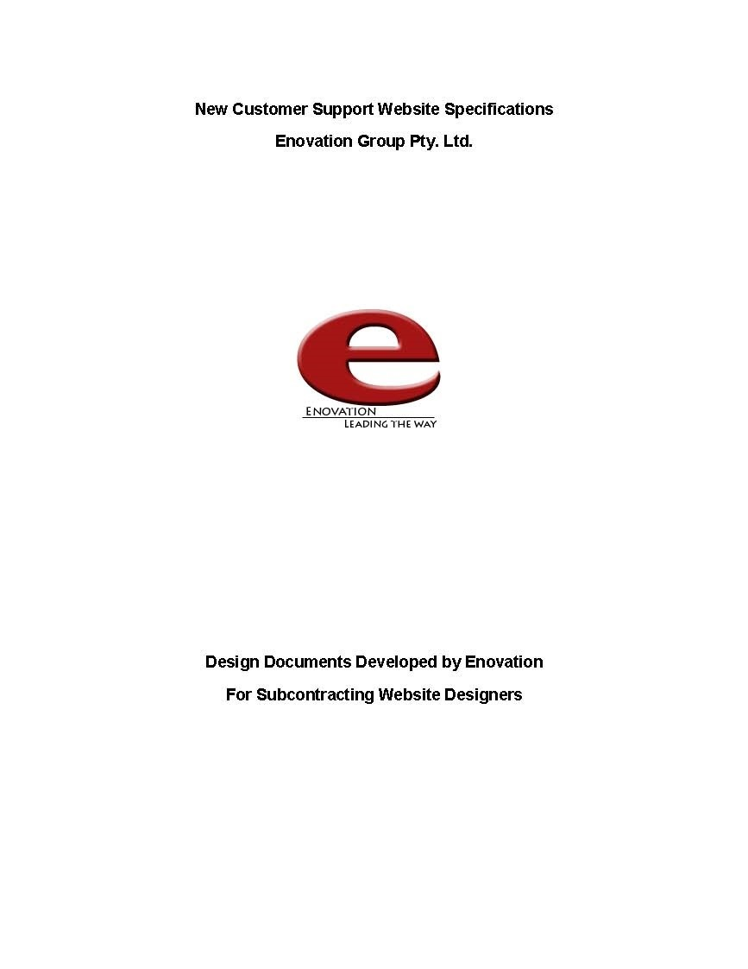

***Table of Contents***

1. Design Brief ........................................................................................................................................ 1
2. Concept Map ...................................................................................................................................... 2
3. CSS Planning ....................................................................................................................................... 2
   1. The CSS layout plan ...................................................................................................................... 3
   2. The CSS text plan .......................................................................................................................... 4
4. Navigation Map (Logical) ................................................................................................................... 6
5. Structure Chart (Physical) .................................................................................................................. 7
6. Storyboards ........................................................................................................................................ 7 Homepage ‐ index.html .................................................................................................................. 8 Changing the Websites Look ‐ changing‐look.html ........................................................................ 9 Changing Images on the Website ‐ changing‐images.html ........................................................... 10 Changing Hyperlinks on a Webpage ‐ changing‐hyperlinks.html ................................................. 11

Changing Text on a Webpage ‐ changing‐text.html ...................................................................... 12 Contact Page ‐ contact.html ......................................................................................................... 13

About Enovation ‐ about‐us.html ................................................................................................. 14 Recommended Links ‐ links.html .................................................................................................. 15

Test Page ‐ advert2.html ............................................................................................................... 16

1. Testing Procedures ........................................................................................................................... 17

**1. Design Brief**

Welcome, it is great to have you on board. You came highly recommended to us as an efficient and capable web developer. I would like to introduce myself, my name is Alex Cowan and I’m the CEO of a medium sized company called Enovation which basically develops websites for small businesses from all over Australia.

To cut a long story short, we have become increasingly busy. This is mainly due to our efforts to stand out from the crowd and provide great customer service. Unfortunately, the customer service has become so busy that our phone lines and employees require some back up. This is where you come in.

We need a site that helps customers update basic things on their websites using a text editor program (something free anyway) because let’s face it, not everyone can afford Adobe Dreamweaver or similar. Most of our customers have little knowledge of XHTML and we want this site to help them. They need to learn that simple text editing may be all that is needed to help maintain a website. This site might also be a way of gaining new clients for us.

I know what you’re thinking, why don’t we do it ourselves? Well, I would get my present web developers to develop the site however they are all booked out until the end of the year on jobs!

Because we are a web development company, we expect a high quality site. However, we will give you most of the content and navigation so it keeps the same “look and feel” of our main website. This web will have a separate URL; however I will need you to upload it onto a server so I can test it properly prior to publishing. (The university tells me that you have your own server there, so maybe this will be a good place to upload it.)

The site will be an advertising support model, that is, it will rely on advertisements (from our other company affiliates) to help pay for it. Sam Browne our amazing I.T lady will help you with all the requirements.

I look forward to viewing your work.

Yours Sincerely,



Alex Cowan. CEO, Enovation Group

P a g e | **1**

**2. Concept Map**

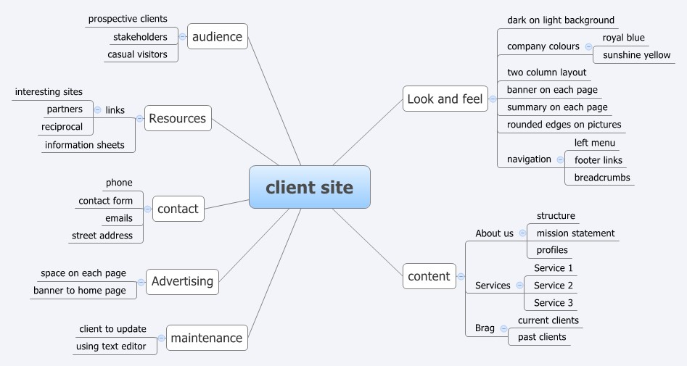

**Concept Map of Enovation’s planned Customer Support Website**

P a g e | **2**

**3. CSS Planning**

## 3.1 The CSS layout plan

The layout for each page on the site will be done using the CSS box model. The layout will be divided up (using divs) into several sections, these sections will be specified in a external CSS style sheet imported into each page on the site.

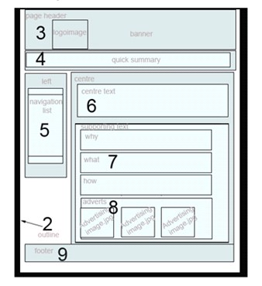

The main sections (divs) are displayed below:

1

1

. container

2

. outline

3

. pageheader

4

. quickSummary

5

. navList

6

. centerText

. supportingText

7

Why

7.1

7.2

What

7.3

How

8

. adverts

9

. footer

**CSS Layout Plan**

This type of a model allows maximum flexibility of the site as each section can be modified with updated requirements. For example if a red border of 2px is desired for the site, the outline (that is itself contained in the page container) section (defined as an ID within the CSS file) can be modified. As the CSS file is imported into all pages any change made to the file is applied to all pages on the site.

P a g e | **3**

## 3.2 The CSS text plan

|  |  |  |  |  |
| --- | --- | --- | --- | --- |
| **enovation-external.css** | **Font Family Text** | **Colour /Special Characteristics** | **Size** | **Align** |
| **body** | Times New Roman, Times, serif | Text Colour #000000  Background image: ../images/wall.jpg (an image file)  Background Size: Cover  Background Position: Centre  Margin and padding: 0  Box Sizing: Border Box | 100% | Left |
| **table** | As body | Width 100%,  Background colour: #989898  1px solid border, Colour black |  | Left |
| **td** | As body | As table |  |  |
| **th** | As body | As table |  |  |
| **h1** | Helvetica, sans-serif | Text Colour #000000 | 5em |  |
| **h3** | Garamond, serif | Text Colour #000000  Background colour #989898 |  |  |
| **p** | As body | Background colour #989898  Colour: Black |  |  |
| **#footer** | As body | Fixed positioning used Top 100, Left 0, Bottom 0, Background Colour: gray  Text Colour: White  Width: 100% |  |  |
| **.container** | As body | Float to left;  Display style: inline |  |  |
| **.topnav** | As body | Overflow hidden;  Background Colour: #333;  Width: 100%; |  |  |
| **.topnav a** | As body | Float to left;  colour: #f2f2f2;  Padding top and botom 14px, left and right16px;  Text Decoration: none; | 17px | Centre |
| **.topnav a:hover** | As body | Background Colour: #ddd;  Colour: black; |  |  |
| **.topnav a.active** | As body | Background colour #989898  Colour: White |  |  |
| **.column** | As body | Float to left  Width: 33.33%  Padding all sides 10px  Height 300px |  |  |
| **.row:after** | As body | Content blank  Display Style: table  Clear: both |  |  |
| **.blue** | Roboto, serif | Text Colour: #000000 |  |  |
| **.a** | Times New Roman, Times, serif | As body |  |  |
| **.b** | Roboto, serif | As body |  |  |
| **#c** | Roboto, serif | As body |  |  |
| **ul** | As body | List Style: Type: square, Position: inside, Color: white;  Text Decoration: underline; |  |  |
| **ol** | As body | List Style: Type: upper-roman, Position: inside, Color: white; |  |  |
| **ul li** | As body | Display style: List item |  |  |
| **ul li a** | Arial | Text Decoration: none;  Padding top and bottom 0, left and right 20px;  Display Style: inline; | 14px |  |

**Note from Bill**: No need to put every detail of CSS in this table, but you should have a fair amount covered, particularly if it deals with the text. This table is a bit on the small side – but this is due to the *“Enovation”* business site using pretty much the same size, and fonts of text throughout the website. Give examples of ID’s Classes, and tags where your text changes are applied. You should also include the CSS for defining XHTML Tables and Forms. If you have more than one CSS file (for example defining media print) you should have multiple tables highlighting what is different between the files.

P a g e | **5**

# Navigation Map (Logical)

**Homepage**

**Customer Support**

**Site**

index.html

Screen ID – 1.0

**Change the Look of**

**your Website**

changing-look.html

Screen ID - 2.1

**Changing Images**

**on your Website**

changing-images.html

Screen ID - 2.2

**Changing**

**Hyperlinks on**

**your Website**

changing-

hyperlinks.html

Screen ID – 2.3

**About the**

**Company**

**(**

**Link located in**

**footer)**

about-us.html

Screen ID – 2.6

**Contact Page**

contact.html

Screen ID – 2.5

**Changing Text**

**on your Website**

changing-text.html

Screen ID – 2.4

**Recommended**

**Reference Links**

links.html

Screen ID – 2.7

**Off Site Links**

**No Return Path**

**Various Web**

**Programming**

**Sites on the**

**Internet**

**Test Link from**

**Advertising on all**

**pages**

advert2.html

Screen ID – 3.0

# Structure Chart (Physical)

Enter the URL of the site here (User Web Root Directory) e.g. http://infotech.scu.edu.au/~bsmart10

**/images /flash-advert2**

advert2.js

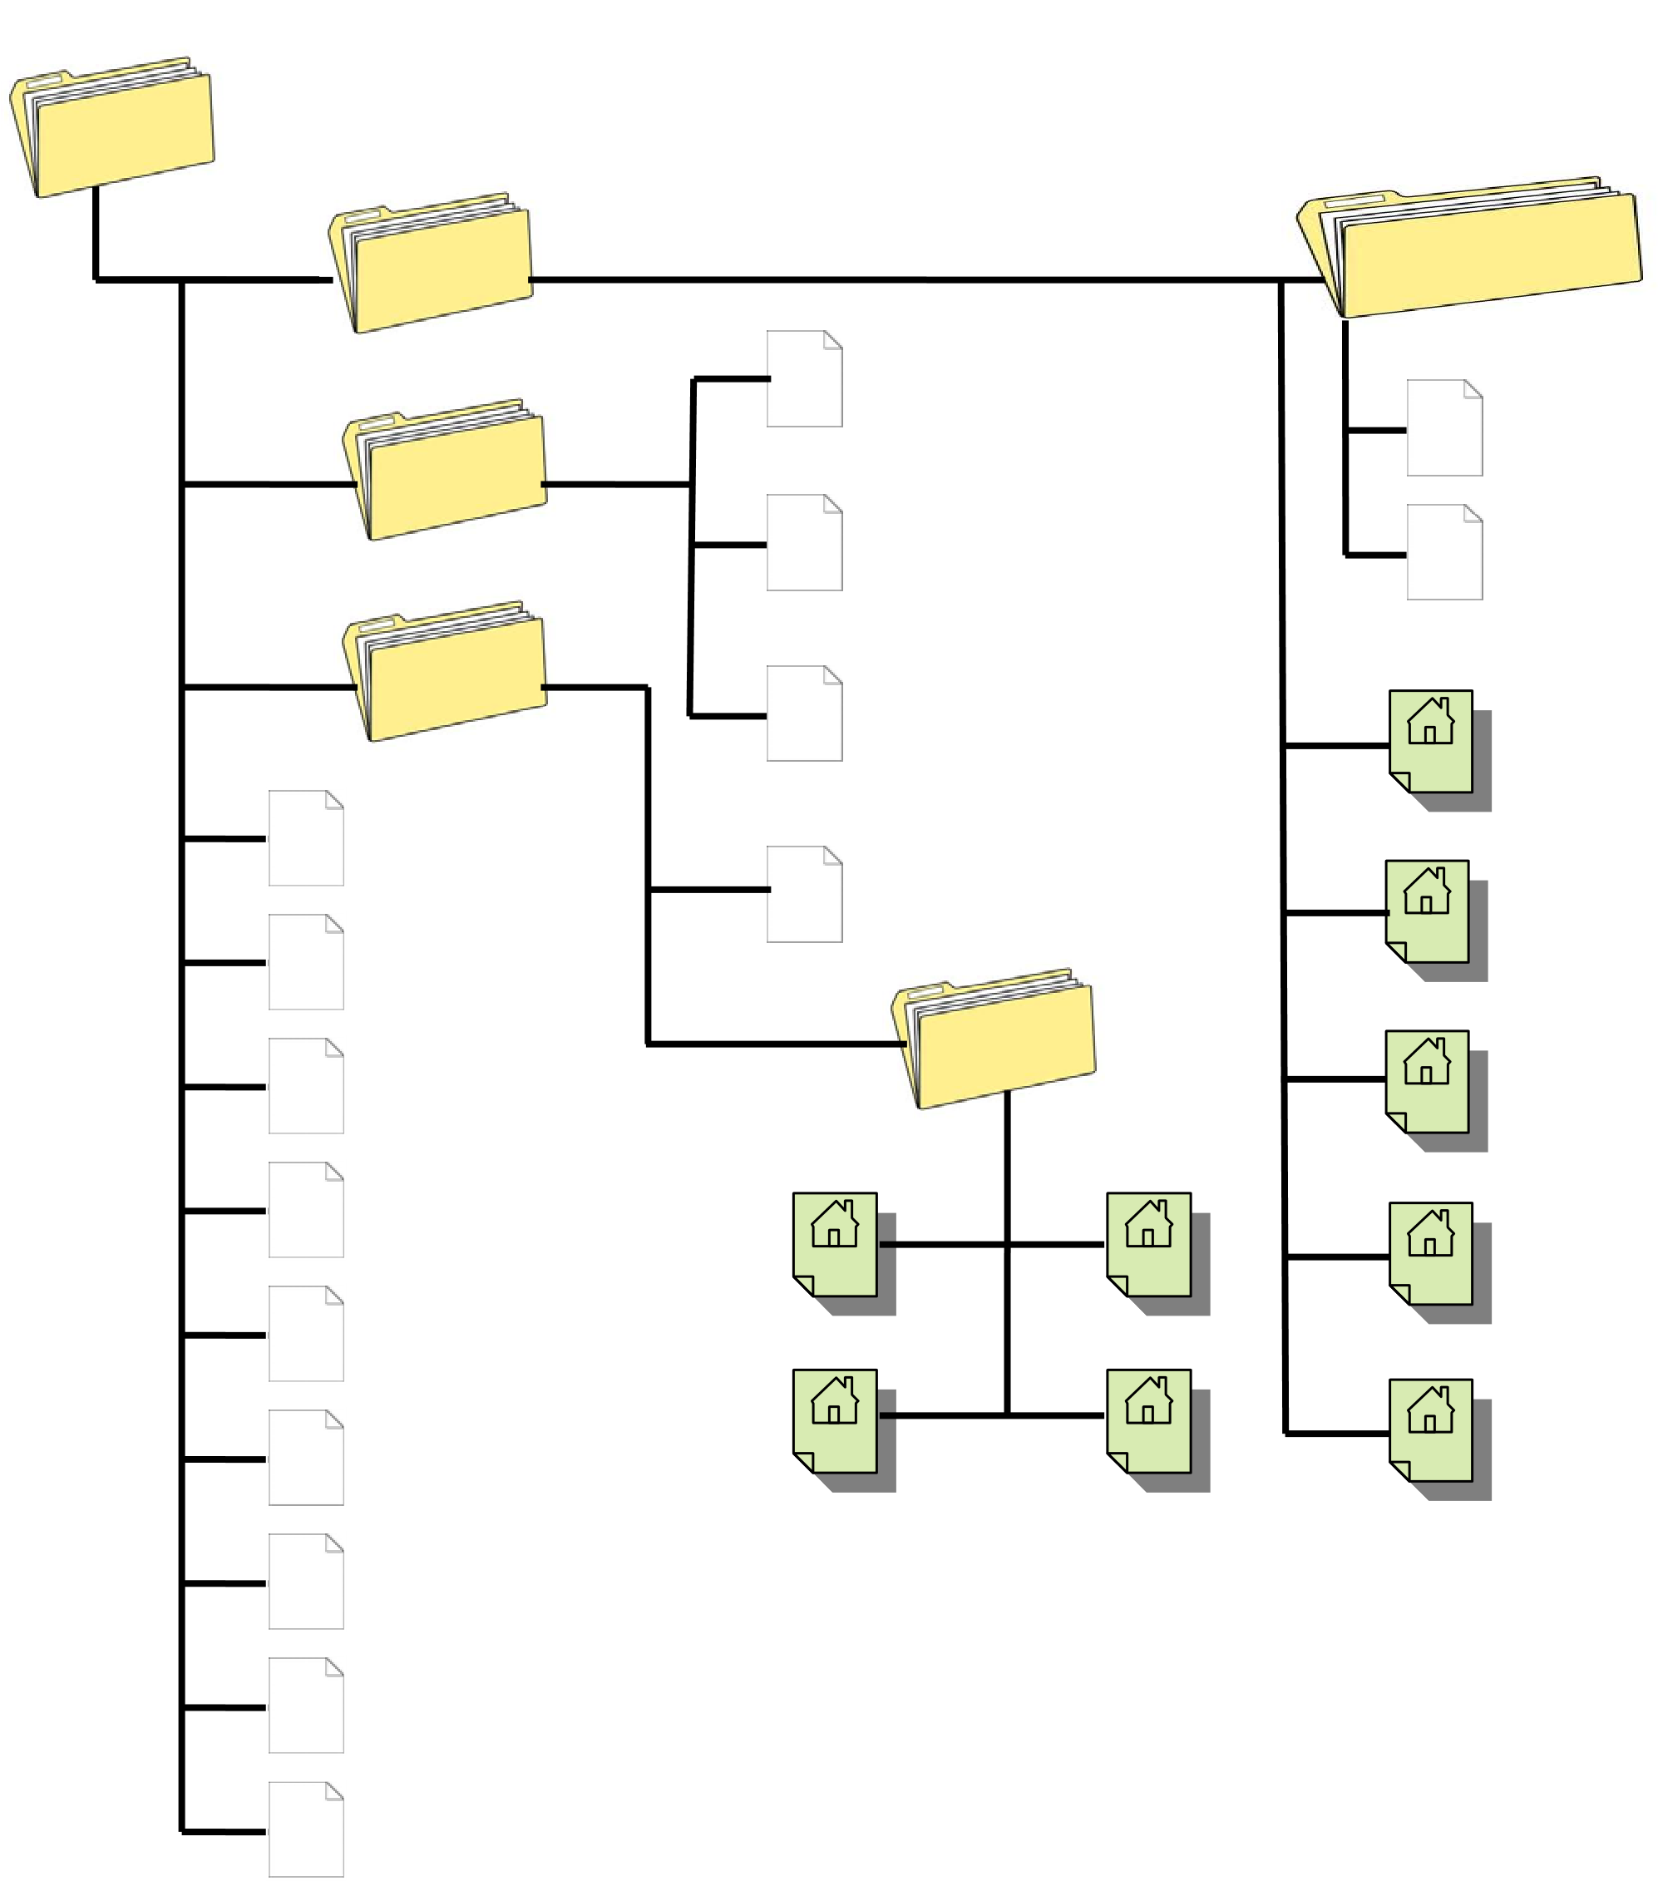 advert2.fla **/scripts**

expressInstall.swf advert2.swf

**/styles** swfobject_modified.js

index.html

enovation-external.css

contact.html

**/images**  about-us.html

advert2.html

links.html

changingtext.html

changing-look.html

|  |
| --- |
| **Note from Bill: In this example all the images used as backgrounds in CSS are located in an images folder within the styles folder, this is one way of**  **storing these background images. The preferred method is to store all images in a single images folder located within the User Root Directory.** |

changing-image.html

changing-hyperlinks.html

# Storyboards

On the following pages each of the nine pages specified in the “***Enovation – Customer Support Website”*** is defined.

**Note from Bill:** Due to the CSS style used to author this site, most pages are extremely similar. This is not always the case, on many sites pages vary greatly. It is due to this reason it is standard practice is to create a storyboard for each page on the website.

P a g e | **7**

|  |  |  |  |  |  |
| --- | --- | --- | --- | --- | --- |
| TITLE: | **Homepage - index.html** | SCREEN ID: | **1.0** | DATE: | 5/01/2012 |



**ELEMENTS:**

GRAPHICS:

Present on this page are several graphics, most used via CSS background images. However,

three advertisements are also present

in the adverts div (8 on picture) .

NOTES:

The image shows each of the divs built for site (site is designed as a standard two column site)

– they are inside the overall container. Immediately in

side the container is the outline (2). All other divs

are within the outline. They are pageHeader (3) is for the company logo, and site banner, quickSummary (4)

can changes on each page - in this case allows an

introduction of the company, navList (5) providing

hyperlinks to most pages on the site, centerText (6)

changes on each page – in this case introducing the

purpose of the website itself, supportingText (7) allows for additional descriptions about the topic of the

centerText (the supportingText div contains three other divs - Why, What & How to allow for multiple

headings and expansion of subject area - all used for the content of this page), adverts (8) providing an

area for advertising Enovations products and Services typically with images and interactive (flash) imaging

(

images used as hyperlinks – at present targets advert

2

.html for testing purposes) and finally footer (9)

contains copyright information and provides links to

Main site (at present target advert2.html) and about-

us.html.

AUDIO/VIDEO:

No audio, – no video, however, site has a flash roll over advertisement (centre

advertisement) to add to interactivity on the site.

TEXT:

On the Homepage introduces the company and informs users of the purpose of the Customer

Support site. The text for this page provided by Enovation_Design_Brief.doc and located in the working

files directory of the Enovation materials.

|  |  |
| --- | --- |
| Description: | Homepage |
| Content: | Brief introduction to company, description of purpose of the Customer Support Website. |
| Interactions: | Navigation links – including a flash rollover advertisement linked to abvert2.html at present (planned to link to main Enovation site) |
| Media Creation: | Nil – provided as part of design package from Enovation. |
| Navigation: | Navigation links to all pages in the site provided by navList div (5) except all three advertisements and the “main site” hyperlink in footer (9) links to advert2.html test page (prior to moving to correct links). Additionally the “About us” hyperlink in the footer (8) links to about-us.html |

|  |  |  |  |  |  |
| --- | --- | --- | --- | --- | --- |
| TITLE: | **Changing the Websites Look - changing-look.html** | SCREEN ID: | **2.1** | DATE: | 12/01/2012 |



**ELEMENTS:**

GRAPHICS:

Present on this page are several graphics, most used via CSS background images. However,

three advertisements are also present

in the adverts div (8 on picture) .

NOTES:

The image shows each of the divs built for site (site is designed as a standard two column site)

– they are inside the overall container. Immediately in

side the container is the outline (2). All other divs

are within the outline. They are pageHeader (3) is for the company logo, and site banner, quickSummary (4)

in this case allows a quick explanation of what the site is for, navList (5) providing hyperlinks to most

pages on the site, centerText (6) changes on each page in this case providing instructions and descriptions

on how to alter CSS on a webpage, supportingText (7)

allows for additional descriptions about the topic of

the centerText (6) - However supportingText (7) is not

used on this page, adve

rts (8) providing an area

for advertising Enovations products and Services ty

pically with images and interactive (flash) imaging

(

images used as hyperlinks – at present targets advert

2

.html for testing purposes) and finally footer (9)

contains copyright information and provides links to

Main site (at present target advert2.html) and about-

us.html.

AUDIO/VIDEO:

No audio, – no video, however, site has a flash roll over advertisement (centre

advertisement) to add to interactivity on the site.

TEXT:

On this page provides instructions and descriptions on how to alter CSS on a webpage. The text

for this page provided by Enovation_Design_Brief.doc and located in the working files directory of the

Enovation materials (

**requires additional research to complete text**

).

|  |  |
| --- | --- |
| Description: | Changing the websites look |
| Content: | Explains to users how to change the look of a website by altering the CSS |
| Interactions: | Navigation links – including a flash rollover advertisement linked to abvert2.html at present (planned to link to main Enovation site) |
| Media Creation: | Nil – provided as part of design package from Enovation. |
| Navigation: | Navigation links to all pages in the site provided by navList div (5) except all three advertisements and the “main site” hyperlink in footer (9) links to advert2.html test page (prior to moving to correct links). Additionally the “About us” hyperlink in the footer (8) links to about-us.html |

|  |  |  |  |  |  |
| --- | --- | --- | --- | --- | --- |
| TITLE: | **Changing Images on the Website - changing-images.html** | SCREEN ID: | **2.2** | DATE: | 11/01/2012 |



**ELEMENTS:**

GRAPHICS:

Present on this page are several graphics, most used via CSS background images.

However, three advertisements are also present in the adverts div (8 on picture) .

NOTES

The image shows each of the divs built for site (site is designed as a standard two column site)

– they are inside the overall container. Immediately in

side the container is the outline (2). All other divs

are within the outline. They are pageHeader (3) is for the company logo, and site banner, quickSummary (4)

in this case allows a quick explanation of what the site is for, navList (5) providing hyperlinks to most

pages on the site, centerText (6) changes on each page

–in this case providing inst

ructions and descriptions

on how to handle images on a website, supportingText (7) allows for additional descriptions about the

topic of the centerText(6) - However supportingText (7)

is not used on this page, adverts (8) providing

an area for advertising Enovations products and Services typically with images and interactive (flash)

imaging (images used as hyperlinks – at present targets advert2.html for testing purposes) and finally

footer (9) contains copyright information and provides links to Main site (at present target advert2.html)

and about-us.html.

AUDIO/VIDEO:

No audio, – no video, however, site has a flash roll over advertisement (centre

advertisement) to add to interactivity on the site.

TEXT:

On this page provides instructions and descriptio

ns on how to handle images on a website. The

text for this page provided by Enovation_Design_Bri

ef.doc and located in the working files directory of

the Enovation materials (

**requires additional research to complete text**

).

|  |  |
| --- | --- |
| Description: | Changing images on a website |
| Content: | Explains to users how to change images located on their website. |
| Interactions: | Navigation links – including a flash rollover advertisement linked to abvert2.html at present (planned to link to main Enovation site) |
| Media Creation: | Nil – provided as part of design package from Enovation. |
| Navigation: | Navigation links to all pages in the site provided by navList div (5) except all three advertisements and the “main site” hyperlink in footer (9) links to advert2.html test page (prior to moving to correct links). Additionally the “About us” hyperlink in the footer (8) links to about-us.html |

|  |  |  |  |  |  |
| --- | --- | --- | --- | --- | --- |
| TITLE: | **Changing Hyperlinks on a Webpage - changing-hyperlinks.html** | SCREEN ID: | **2.3** | DATE: | 14/01/2012 |



**ELEMENTS:**

GRAPHICS:

Present on this page are several graphics, most used via CSS background images.

However, three advertisements are also present in the adverts div (8 on picture) .

NOTES:

The image shows each of the divs built for site (site is designed as a standard two column site)

– they are inside the overall container. Immediately in

side the container is the outline (2). All other divs

are within the outline. They are pageHeader (3) is for the company logo, and site banner, quickSummary (4)

in this case allows a quick explanation of what the site is for, navList (5) providing hyperlinks to most

pages on the site, centerText (6) changes on each page

–in this case providing inst

ructions and descriptions

on how use and change hyperlinks on webpages., supportingText (7) allows for additional descriptions

about the topic of the centerText (6) - However supporti

ngText (7) is not used on this page, adverts (8)

providing an area for advertising En

ovations products and Services typically with images and interactive

(

flash) imaging (images used as hyperlinks – at present targets advert2.html for testing purposes) and

finally footer (9) contains copyright information and provides links to Main site (at present target

advert2.html) and about-us.html.

AUDIO/VIDEO:

No audio, – no video, however, site has a flash roll over advertisement (centre

advertisement) to add to interactivity on the site.

TEXT:

On this page provides instructions and descript

ions on how to use and change hyperlinks on

webpages. The text for this page provided by Enovat

ion_Design_Brief.doc and located in the working files

directory of the Enovation materials (

**requires additional research to complete text**

).

|  |  |
| --- | --- |
| Description: | Changing hyperlinks on a website |
| Content: | Explains to users how to change to use and change hyperlinks on webpages. |
| Interactions: | Navigation links – including a flash rollover advertisement linked to abvert2.html at present (planned to link to main Enovation site) |
| Media Creation: | Nil – provided as part of design package from Enovation. |
| Navigation: | Navigation links to all pages in the site provided by navList div (5) except all three advertisements and the “main site” hyperlink in footer (9) links to advert2.html test page (prior to moving to correct links). Additionally the “About us” hyperlink in the footer (8) links to about-us.html |

|  |  |  |  |  |  |
| --- | --- | --- | --- | --- | --- |
| TITLE: | **Changing Text on a Webpage - changing-text.html** | SCREEN ID: | **2.4** | DATE: | 13/01/2012 |



**ELEMENTS:**

GRAPHICS:

Present on this page are several graphics, most used via CSS background images.

However, three advertisements are also present in the adverts div (8 on picture) .

NOTES:

The image shows each of the divs built for site (site is designed as a standard two column site)

– they are inside the overall container. Immediately in

side the container is the outline (2). All other divs

are within the outline. They are pageHeader (3) is for the company logo, and site banner, quickSummary (4)

in this case allows a quick explanation of what the site is for, navList (5) providing hyperlinks to most

pages on the site, centerText (6) changes on each page –in this case how to use and change the text

(

colour, alignment spacing etc.) on a webpage (presented

in tabular form). supportingText (7) allows for

additional descriptions about the topic of the centerTe

xt (6) - However supportingText (7) is not used on

this page, adverts (8) providing an area for advertis

ing Enovations products and Services typically with

images and interactive (flash) imaging (images used as hyperlinks – at present targets advert2.html for

testing purposes) and finally footer

(9)

contains copyright information an

d provides links to Main site (at

present target advert2.html) and about-us.html.

AUDIO/VIDEO:

No audio, – no video, however, site has a flash roll over advertisement (centre

advertisement) to add to interactivity on the site.

TEXT:

On this page provides instructions and descriptions on how to use and change the text (colour,

alignment spacing etc.) on a webpage (presented in tabular form). The text for this page provided by

Enovation_Design_Brief.doc and located in the working files directory of the Enovation materials ..

|  |  |
| --- | --- |
| Description: | Changing text on a webpage |
| Content: | Explains to users how to change the text (colour, alignment spacing etc.) on a webpage (presented in tabular form). |
| Interactions: | Navigation links – including a flash rollover advertisement linked to abvert2.html at present (planned to link to main Enovation site) |
| Media Creation: | Nil – provided as part of design package from Enovation. |
| Navigation: | Navigation links to all pages in the site provided by navList div (5) except all three advertisements and the “main site” hyperlink in footer (9) links to advert2.html test page (prior to moving to correct links). Additionally the “About us” hyperlink in the footer (8) links to about-us.html |

|  |  |  |  |  |  |
| --- | --- | --- | --- | --- | --- |
| TITLE: | **Contact Page - contact.html** | SCREEN ID: | **2.5** | DATE: | 16/01/2012 |



**ELEMENTS:**

GRAPHICS:

Present on this page are several graphics, most used via CSS background images.

However, three advertisements are also present in the adverts div (8 on picture) .

NOTES:

The image shows each of the divs built for site (site is designed as a standard two column site)

– they are inside the overall container. Immediately in

side the container is the outline (2). All other divs

are within the outline. They are pageHeader (3) is for the company logo, and site banner, quickSummary (4)

in this case allows a quick explanation of what the site is for, navList (5) providing hyperlinks to most

pages on the site, centerText (6) changes on each page –in this case the contact details for Enovation.

supportingText (7) allows for addi

tional descriptions about the topic of the centerText (6) - However

supportingText (7) is not used on this page, adve

rts (8) providing an area for advertising Enovations

products and Services typically with images and interactive (flash) imaging (images used as hyperlinks – at

present targets advert2.html for testing purposes) and finally footer (9) contains copyright information

and provides links to Main site (at present target advert2.html) and about-us.html.

AUDIO/VIDEO:

No audio, – no video, however, site has a flash roll over advertisement (centre

advertisement) to add to interactivity on the site.

TEXT:

On this page provides contact detail (phone/fax/e

mail) for Enovation PTY. LTD. The text for this

page provided by Enovation_Design_Brief.doc and loca

ted in the working files directory of the Enovation

materials.

|  |  |
| --- | --- |
| Description: | Contact Page |
| Content: | This page provides contact detail (phone/fax/email) for Enovation PTY. LTD. |
| Interactions: | Navigation links – including a flash rollover advertisement linked to abvert2.html at present (planned to link to main Enovation site) |
| Media Creation: | Nil – provided as part of design package from Enovation. |
| Navigation: | Navigation links to all pages in the site provided by navList div (5) except all three advertisements and the “main site” hyperlink in footer (9) links to advert2.html test page (prior to moving to correct links). Additionally the “About us” hyperlink in the footer (8) links to about-us.html |

|  |  |  |  |  |  |
| --- | --- | --- | --- | --- | --- |
| TITLE: | **About Enovation - about-us.html** | SCREEN ID: | **2.6** | DATE: | 20/01/2012 |



**ELEMENTS:**

GRAPHICS:

Present on this page are several graphics, most used via CSS background images.

However, three advertisements are also present in the adverts div (8 on picture).

NOTES:

The image shows each of the divs built for site (site is designed as a standard two column site)

– they are inside the overall container. Immediately in

side the container is the outline (2). All other divs

are within the outline. They are pageHeader (3) is for the company logo, and site banner, quickSummary (4)

in this case allows a quick explanation of what the site is for, navList (5) providing hyperlinks to most

pages on the site, centerText (6) changes on each page –in this case the history/mission/goals details for

Enovation. supportingText (7) allows for additional

descriptions about the topic of the centerText(6) -

However supportingText (7) is not used on this pa

ge, adverts (8) providing an area for advertising

Enovations products and Services typically with images and interactive (flash) imaging (images used as

hyperlinks – at present targets advert2.html for testing purposes) and finally footer (9) contains

copyright information and provides links to Main site (at present target advert2.html) and about-us.html.

AUDIO/VIDEO:

No audio, – no video, however, site has a flash roll over advertisement (centre

advertisement) to add to interactivity on the site.

TEXT:

On this page provides history/mission/goals of Enovation PTY LTD. The text for this page

provided by Enovation_Design_Brief.doc and located in the working files directory of the Enovation

materials.

|  |  |
| --- | --- |
| Description: | About Enovation |
| Content: | Provides and describes the history/mission/goals of Enovation PTY LTD. |
| Interactions: | Navigation links – including a flash rollover advertisement linked to abvert2.html at present (planned to link to main Enovation site) |
| Media Creation: | Nil – provided as part of design package from Enovation. |
| Navigation: | Navigation links to all pages in the site provided by navList div (5) except all three advertisements and the “main site” hyperlink in footer (9) links to advert2.html test page (prior to moving to correct links). Additionally the “About us” hyperlink in the footer (8) links to about-us.html |

|  |  |  |  |  |  |
| --- | --- | --- | --- | --- | --- |
| TITLE: | **Recommended Links - links.html** | SCREEN ID: | **2.7** | DATE: | 7/01/2012 |



**ELEMENTS:**

GRAPHICS:

Present on this page are several graphics, most used via CSS background images.

However, three advertisements are also present in the adverts div (8 on picture).

NOTES:

The image shows each of the divs built for site (site is designed as a standard two column site)

– they are inside the overall container. Immediately in

side the container is the outline (2). All other divs

are within the outline. They are pageHeader (3) is for the company logo, and site banner, quickSummary (4)

in this case allows a quick explanation of what the site is for, navList (5) providing hyperlinks to most

pages on the site, centerText (6) changes on each page –in this case it provides resources to the users by

giving them many offsite hyperlinks

and descriptions of web developmen

t sites. supportingText (7) allows

for additional descriptions about the topic of the centerText (6) - However supportingText (7) is not

used on this page, adverts (8) providing an area for

advertising Enovations products and Services typically

with images and interactive (flash) imaging (images used as hyperlinks – at present targets advert2.html

for testing purposes) and finally footer (9) contains copyright information and provides links to Main site

(

at present target advert2.html) and about-us.html.

AUDIO/VIDEO:

No audio, – no video, however, site has a flash roll over advertisement (centre

advertisement) to add to interactivity on the site.

TEXT:

On this page is a list (with links) to several web development sites coving a wide range of

technologies, design and resources. The text for th

is page provided by Enov

ation_Design_Brief.doc and

located in the working files directory of the Enovation materials.

|  |  |
| --- | --- |
| Description: | Recommended Links |
| Content: | On this page is a list (with links) to several web development sites coving a wide range of technologies, design and resources. |
| Interactions: | Navigation links – – including a flash rollover advertisement linked to abvert2.html at present (planned to link to main Enovation site). Additionally this page has many links to (off-site) online resources for web developers. |
| Media Creation: | Nil |
| Navigation: | Navigation links to all pages in the site provided by navList div (5) except all three advertisements and the “main site” hyperlink in footer (9) links to advert2.html test page (prior to moving to correct links). Additionally the “About us” hyperlink in the footer (8) links to about-us.html. Page also contains many offsite links to various recommended web development sites. |

|  |  |  |  |  |  |
| --- | --- | --- | --- | --- | --- |
| TITLE: | **Test Page - advert2.html** | SCREEN ID: | **3.0** | DATE: | 8/01/2012 |

|  |  |
| --- | --- |
| Description: | Test Page |
| Content: | This is a test page for the links associated with the advertisements and “Main site” link in the footer of the site. These will be change to the appropriate site on Enovation corporate site at the completion of the project. |
| Interactions: | Navigation links – – including a flash rollover advertisement linked to this page. It is planned to link to main Enovation site. |
| Media Creation: | Nil |
| Navigation: | Navigation links to pages within the site, featured project link to portfolio page, quick contact form, hire me ad links to contact page and social media links to applicable social media pages |



**ELEMENTS:**

GRAPHICS:

Present on this page are several graphics, most used via CSS background images.

However, three advertisements are also present in the adverts div (8 on picture).

NOTES:

The image shows each of the divs built for site (site is designed as a standard two column site)

– they are inside the overall container. Immediately in

side the container is the outline (2). All other divs

are within the outline. They are pageHeader (3) is for the company logo, and site banner, quickSummary (4)

in this case allows a quick explanation of what the site is for, navList (5) providing hyperlinks to most

pages on the site, centerText (6) changes on each page –in this case it provides a notice that this is a test

page (and a link to contact.html), supportingText (7) allows for additional descriptions about the topic of

the centerText (6) - However supportingText (7) is not used on this page, adverts (8) providing an area

for advertising Enovations products and Services ty

pically with images and interactive (flash) imaging

(

images used as hyperlinks – at present targets advert

2

.html for testing purposes) and finally footer (9)

contains copyright information and provides links to

Main site (at present target advert2.html) and about-

ushtml

AUDIO/VIDEO:

No audio, – no video, however, site has a flash roll over advertisement (centre

advertisement) to add to interactivity on the site

TEXT:

This is a test page for the links associated with the advertisements and “Main site” link in the

footer of the site. These will be change to the appropriate site on Enovation corporate site at the

completion of the project. The text for this page provided by Enovation_Design_Brief.doc and located in

the working files directory of the Enovation materials.

# Testing Procedures

Testing procedure for this Website is as follows.

* Validation of Files o All XHTML pages will be validated using XHTML 1.0 Transitional o All CSS files will be validated using CSS Level 2.1
* Test “:Look and Feel” of display on several browser sizes o 640 X 480 pixels, o 800 X 600 pixels, o 1024 X 768 pixels, o 1280 X 1024 pixels, o 1440 x 900 pixels, o 1280 x 854 pixels, o 1600 x 1024 pixels.
* Test “Look and Feel” of site on different browsers o Internet Explorer 8 (Windows XP) o Internet Explorer 9 (Windows 7) o Firefox 9.0.1 (Mozilla) o Chrome (Google) o Safari 5 (Apple)

o Opera version 11.60 (Opera Software ASA)

* Test all hyperlinks on site o All internal links (site navigation) o All external hyperlinks.
* Test proper functioning of all media on site o Images o Audio, o Video, o Flash.
* Test proper functioning of all JavaScript o Dynamic JavaScript (if used) o Form JavaScript

P a g e | **17**